PRESS KIT

Factsheet

Company:
Evil Bunneh
Based in Winnipeg, MB Canada

Founding date:
Dec 15, 2018

Website:
www.evil-bunneh.com

Press / Business contact:
contact@evil-bunneh.com

Social:
Twitter
Facebook
Steam

Releases:
Evil Bunneh Releases

Company Description
Evil Bunneh is an INDIE game development company based out of Canada.
Game development is our passion, with years of gaming experience behind us that contribute to our innovative vision and development approach. The company was founded in 2018, by a small team of developers with over 10 years of game development experience and history.
We aim to deliver the best, fun and unique game experience to our community.

ABOUT Frontier - Tactical Response Squad

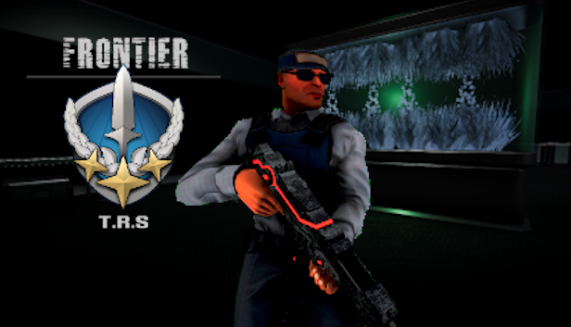

Overview

In Frontier - TRS, players will take control of one of the elite security clone operatives and combat the rebellion forces to secure a high-tech research facility and it's personnel. In the beginning of each game sessions, players are able to configure the session length.

Depending on the size of the session, the levels will be randomly generated, ensuring unique gameplay experience with every play through. Hunt down the attackers and take them out. Find and secure the hostages. Use the environment to your advantage while moving through a futuristic, high-tech facilities.

The Story

In the end of the 21st century, mega corporations came to power through corruption in the governments of the world. Driven only by profits, these corporations mined resources to fuel their production machines. As a result, severe climate changes occurred across the planet.

With harsh weather conditions and heavy pollution, most of the planet became nearly uninhabitable. While the majority of people were suffering in the slums, the elite of humanity enjoyed their privileged life in an isolated high-tech, self-sustained bio domes.

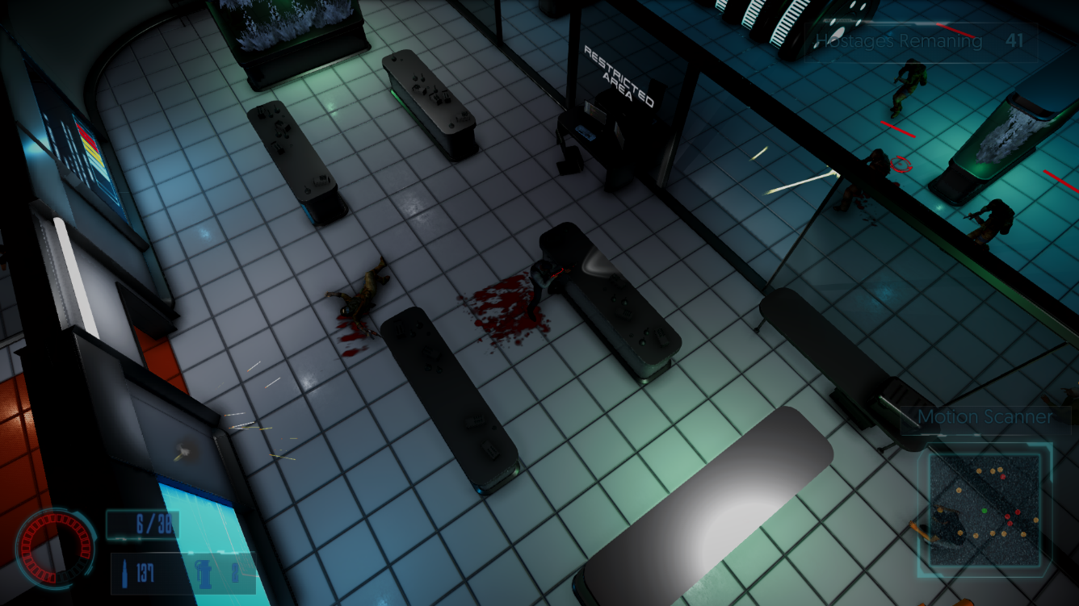

The primary object of their obsession was an extract from genetically engineered plant in the corporation’s laboratories, that greatly extended human life span and granted immunity from diseases. With this product on the market, the corporations gained ultimate control over the domes and their governors.

Many rebellion groups rose up from the ashes and fought the elite in an attempt to overthrow the government. These groups were declared a high threat and corporation were given full authority to deal with this threat by any means necessary.
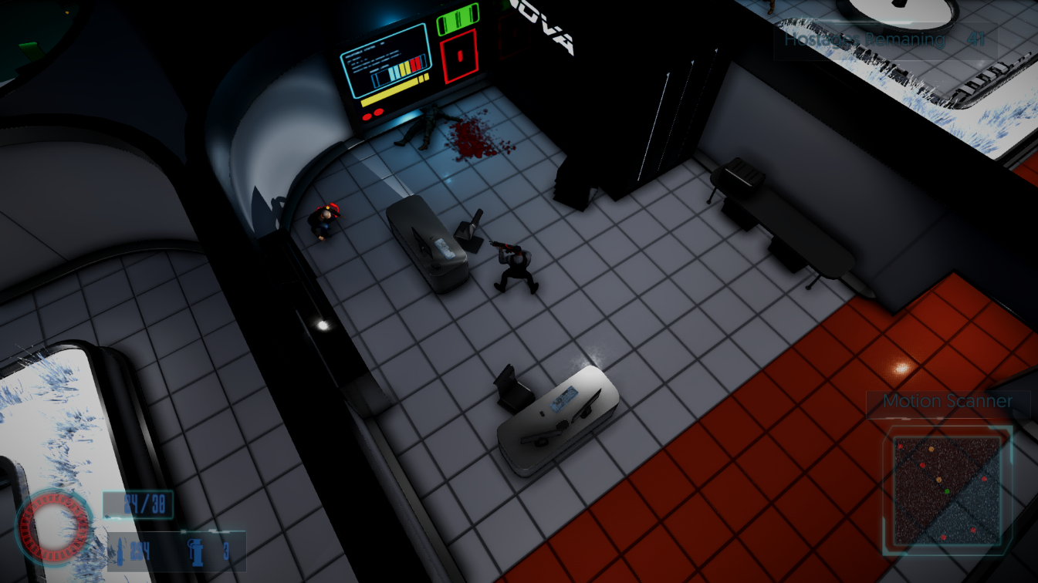

To counter the rebellion threat and ensure a stable production of the product, a special type of clones was genetically produced as means of security. These clones were placed inside the facilities and were only activated in case of an immediate threat. Their only objective was to eliminate the rebel threat and secure the elite personnel.
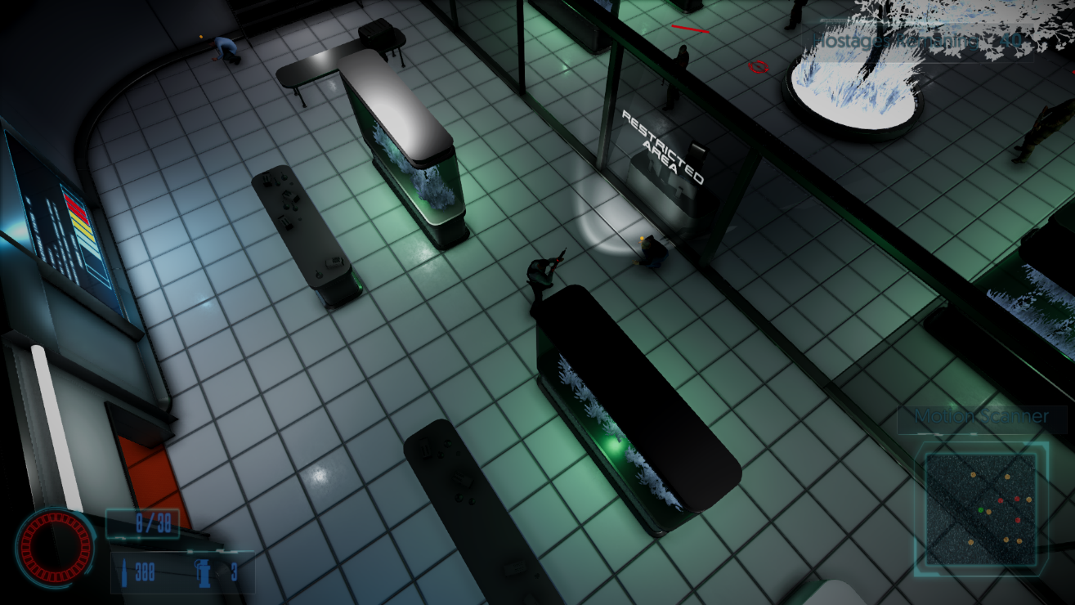

Gameplay Diversity

Each time a player starts a new session, our advanced level generation system will build, evaluate and populate a completely randomly generated level for the selected session. This approach allows for high re-playability and unique experience with every playthrough.

